ASSIGNMENT NO. 10
Window Functions and Analytical Queries

Objective: To use ROW_NUMBER(), RANK(), PARTITION BY, OVER(), running totals, and analytical queries in MySQL

Q1) Create SalesDB and SalesData and insert at least 12 records belonging to three departments.

Column Name | Data Type | Constraint
SaleID | INT | PRIMARY KEY
Salesperson | VARCHAR(50) | NOT NULL
Department | VARCHAR(30) | NOT NULL
SaleDate | DATE | NOT NULL
Amount | DECIMAL(10,2) | NOT NULL

DROP DATABASE IF EXISTS SalesDB_Assignment10;
CREATE DATABASE SalesDB_Assignment10;
USE SalesDB_Assignment10;

CREATE TABLE SalesData (
SaleID INT PRIMARY KEY,
Salesperson VARCHAR(50) NOT NULL,
Department VARCHAR(30) NOT NULL,
SaleDate DATE NOT NULL,
Amount DECIMAL(10,2) NOT NULL
);

INSERT INTO SalesData (SaleID, Salesperson, Department, SaleDate, Amount) VALUES
(1, 'Aarav Shah', 'Electronics', '2026-01-05', 50000.00),
(2, 'Priya Patil', 'Furniture', '2026-01-08', 40000.00),
(3, 'Rohan Desai', 'Electronics', '2026-01-12', 65000.00),
(4, 'Sneha Joshi', 'Furniture', '2026-01-15', 55000.00),
(5, 'Karan Mehta', 'Electronics', '2026-02-05', 65000.00),
(6, 'Meera Kulkarni', 'Furniture', '2026-02-10', 30000.00),
(7, 'Neha Shah', 'Clothing', '2026-02-12', 45000.00),
(8, 'Aman Verma', 'Clothing', '2026-02-18', 45000.00),
(9, 'Divya More', 'Electronics', '2026-03-03', 80000.00),
(10, 'Rahul Sharma', 'Furniture', '2026-03-06', 60000.00),
(11, 'Isha Nair', 'Clothing', '2026-03-10', 70000.00),
(12, 'Om Jadhav', 'Electronics', '2026-03-14', 55000.00);

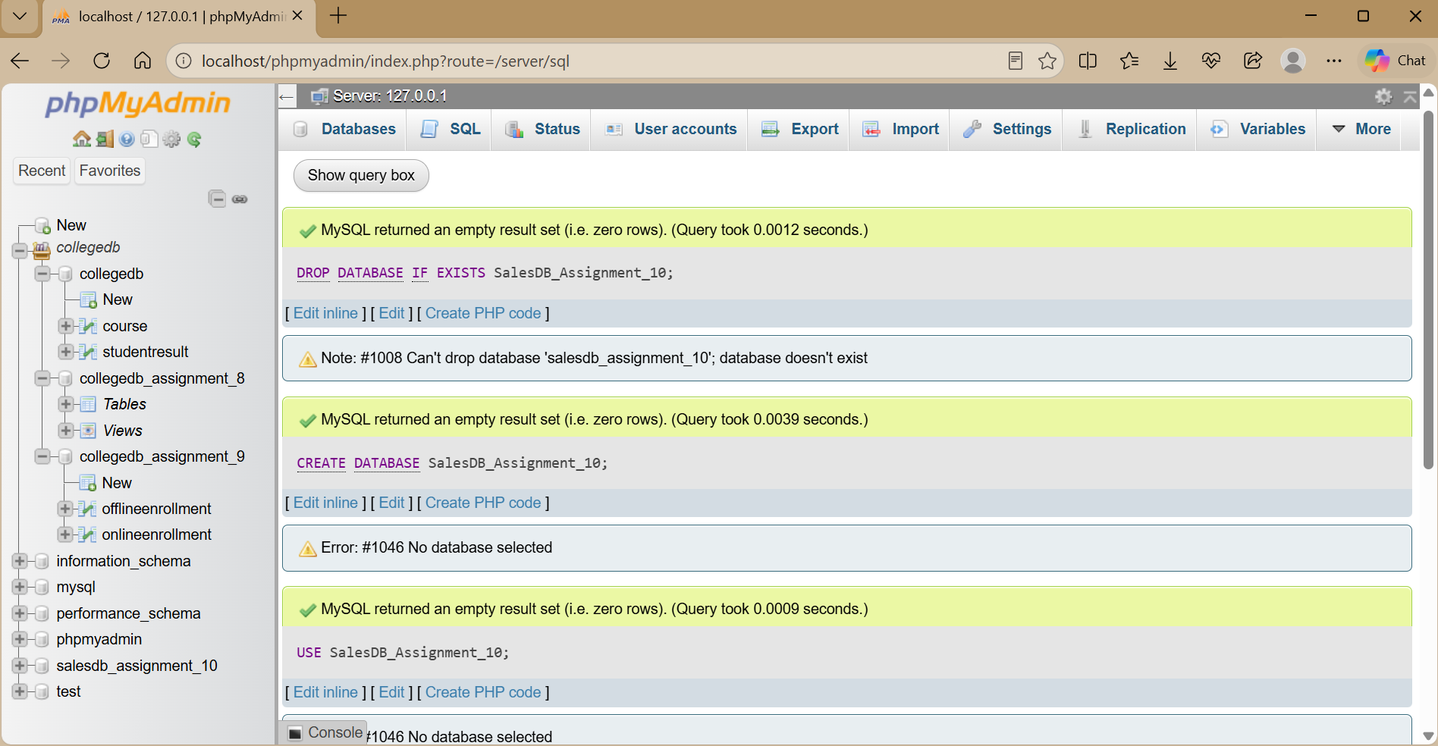

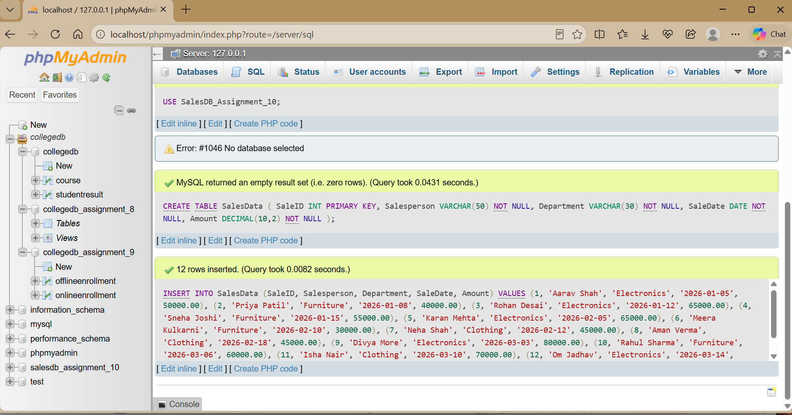

Q2) Use ROW_NUMBER() to assign a unique row number to every salesperson.

SELECT
Salesperson, Department, Amount, ROW_NUMBER() OVER (
ORDER BY Amount DESC, SaleID ASC
) AS SalesRowNumber FROM SalesData;

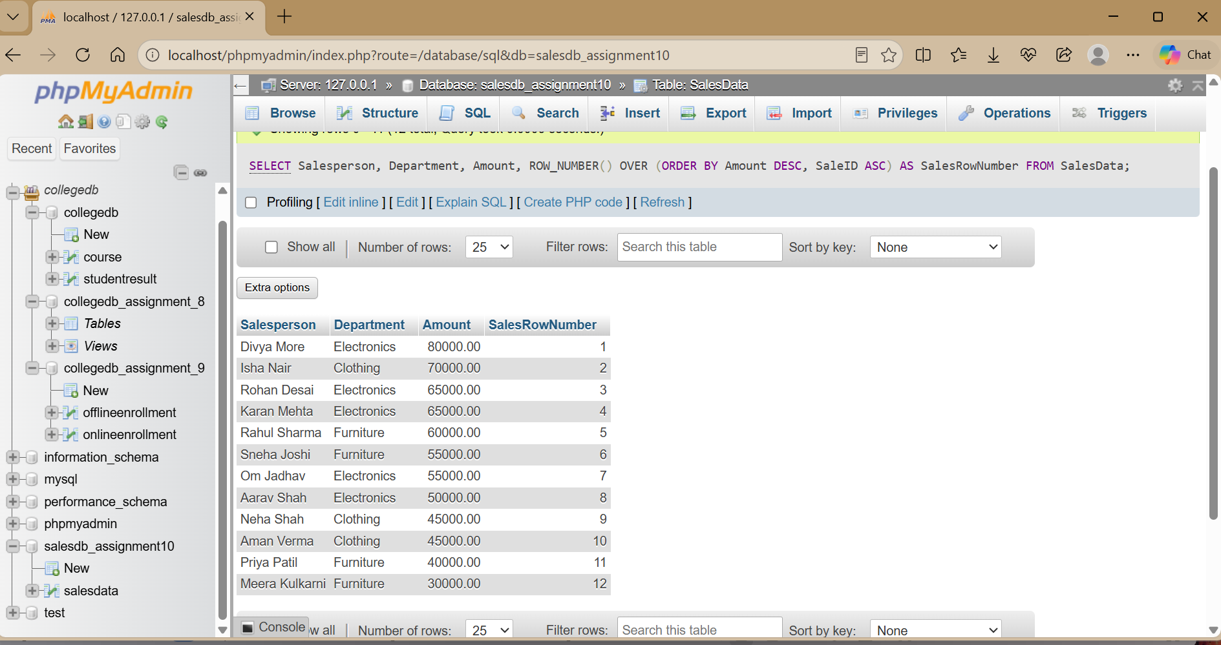

ROW_NUMBER() gives every row a unique sequential number, including rows with equal amounts.

Q3) Use RANK() to rank salespersons according to sale amount.

SELECT
Salesperson, Department, Amount, RANK() OVER (
ORDER BY Amount DESC

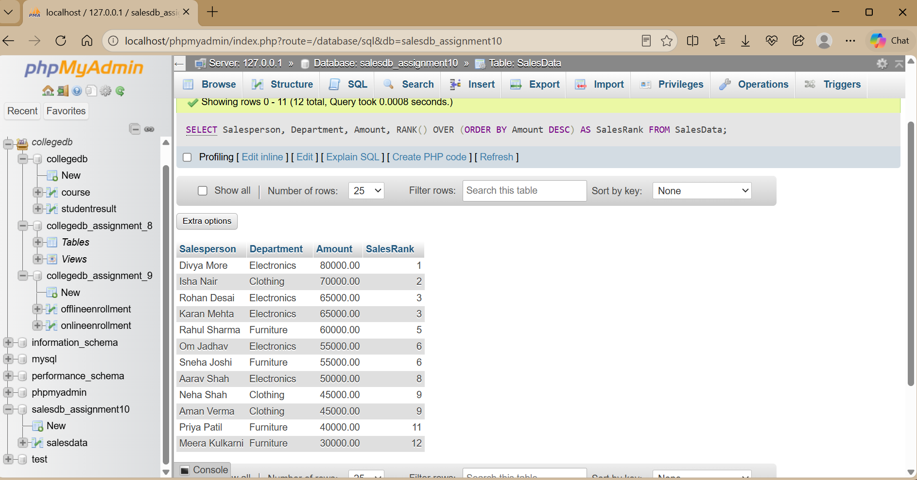

RANK() gives equal values the same rank. The next rank can contain a gap when ties occur.

Q4) Rank salespersons separately within each department.

SELECT
Salesperson, Department, Amount, RANK() OVER (
PARTITION BY Department ORDER BY Amount DESC
) AS DepartmentRank FROM SalesData
ORDER BY Department, DepartmentRank;

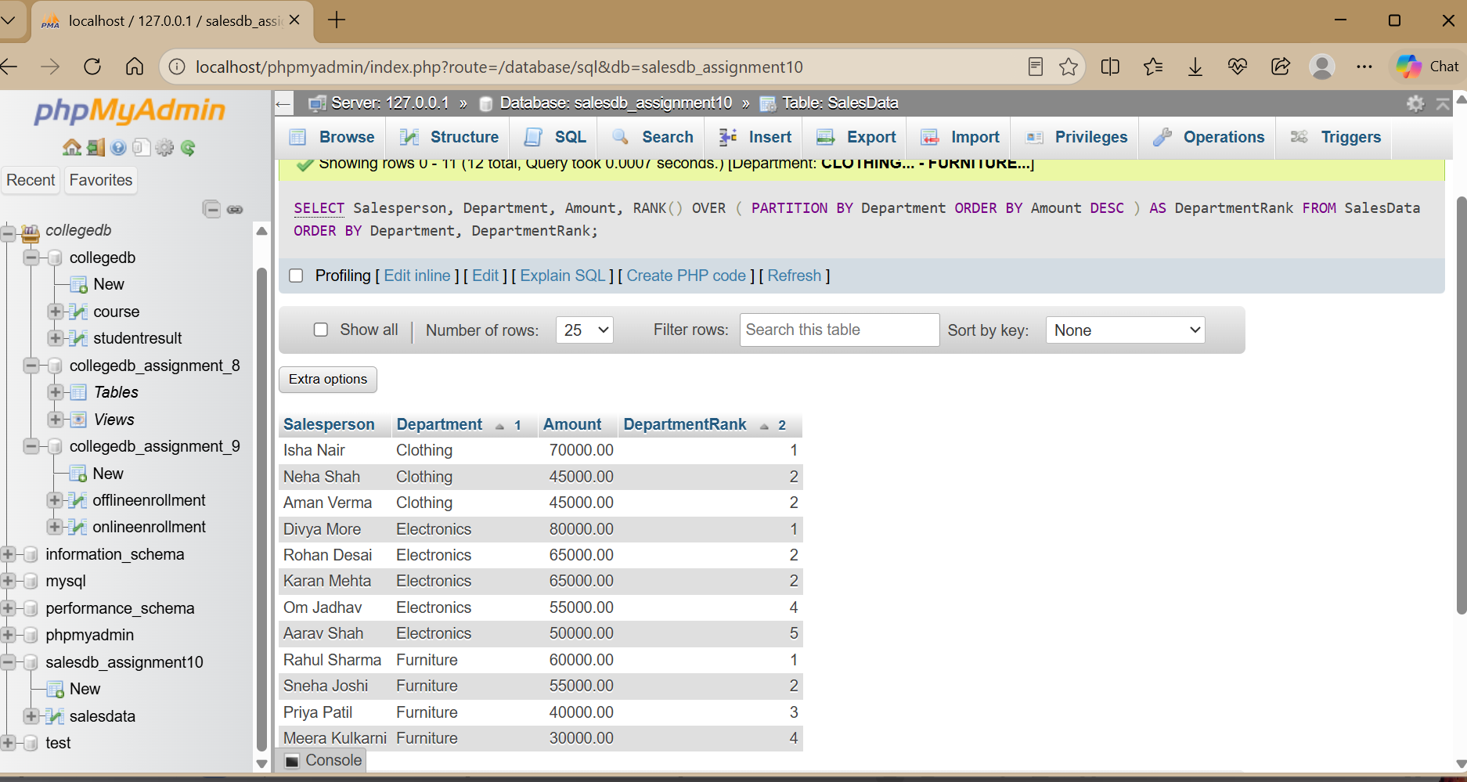

PARTITION BY creates a separate analytical group for each department, so ranking restarts within every department.

Q5) Calculate the running total of sales according to sale date.

SELECT
SaleID, Salesperson, SaleDate, Amount,
SUM(Amount) OVER (
ORDER BY SaleDate, SaleID
ROWS BETWEEN UNBOUNDED PRECEDING AND CURRENT ROW
) AS RunningTotal FROM SalesData
ORDER BY SaleDate, SaleID;

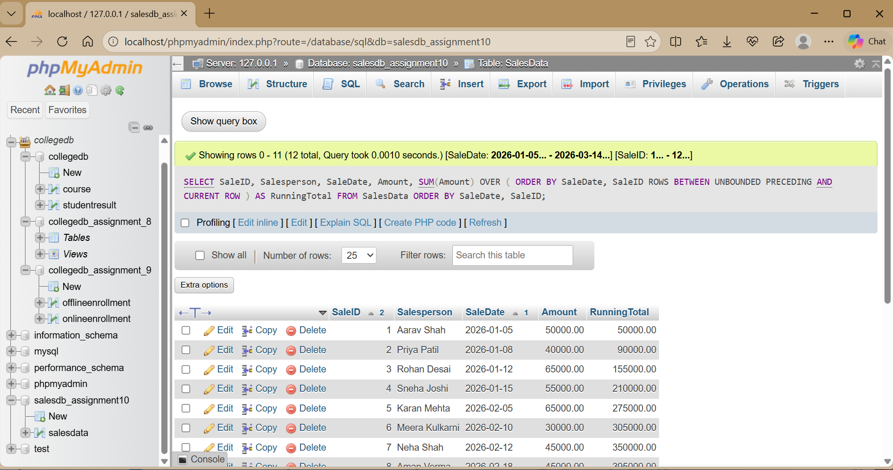

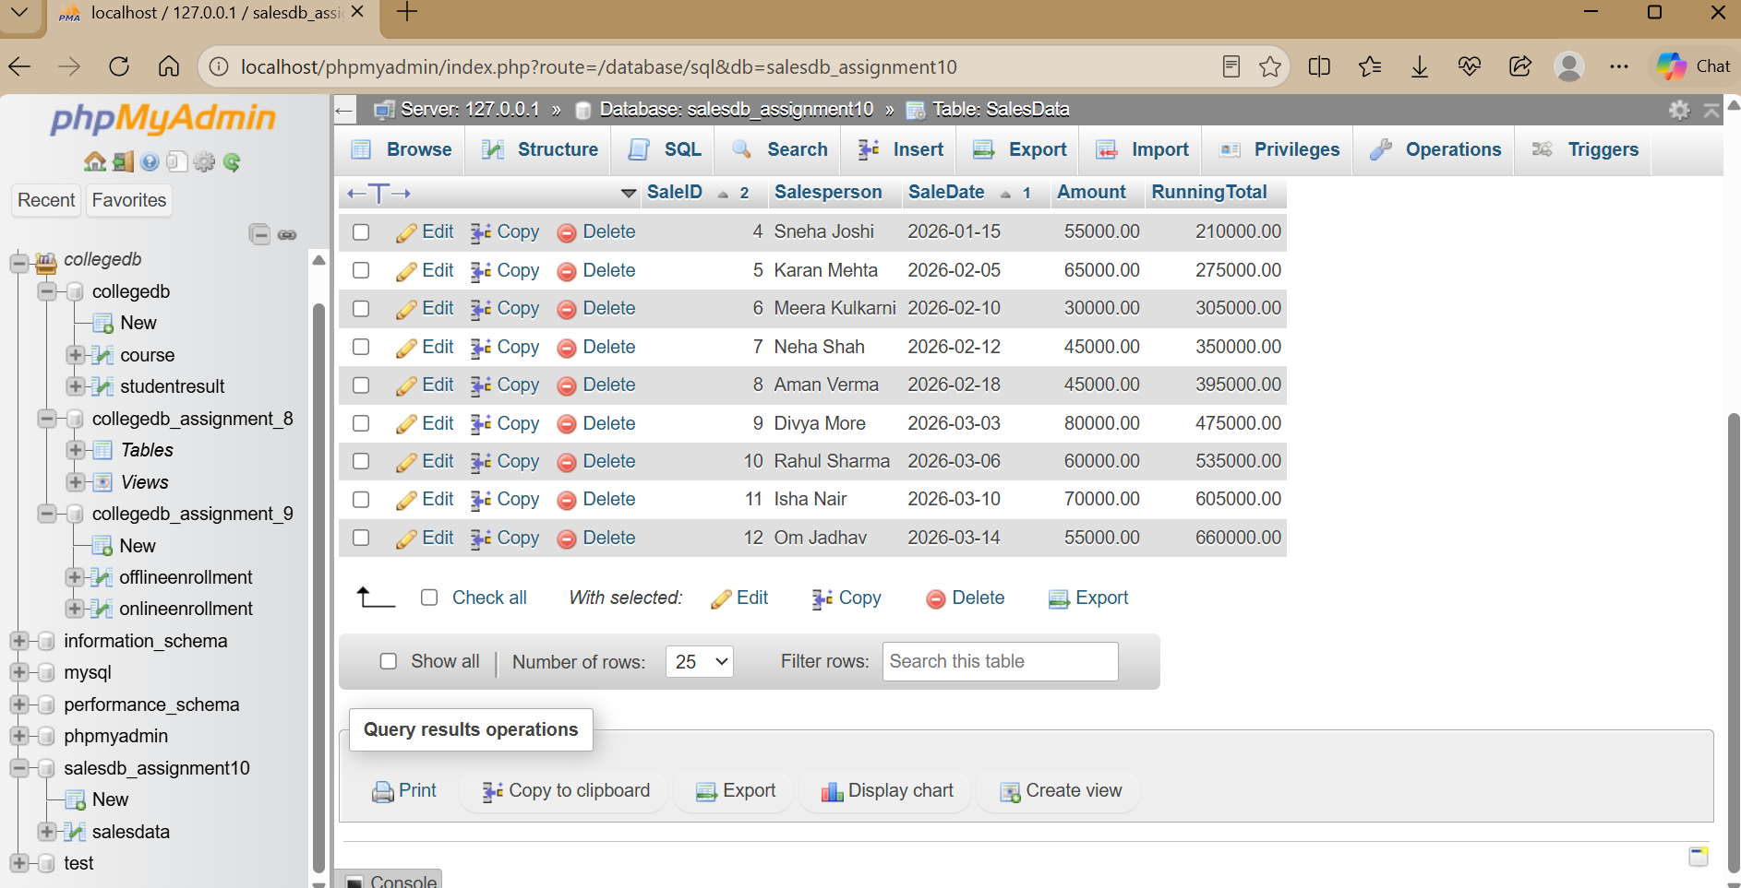
The running total starts with the first sale and accumulates the amount row by row.

Q6) Display the highest-performing salesperson from each department.

SELECT
Salesperson, Department, Amount
FROM (
SELECT
Salesperson, Department, Amount, ROW_NUMBER() OVER (
PARTITION BY Department
ORDER BY Amount DESC, SaleID ASC
) AS DepartmentRowNumber FROM SalesData
) AS DepartmentSales
WHERE DepartmentRowNumber = 1;

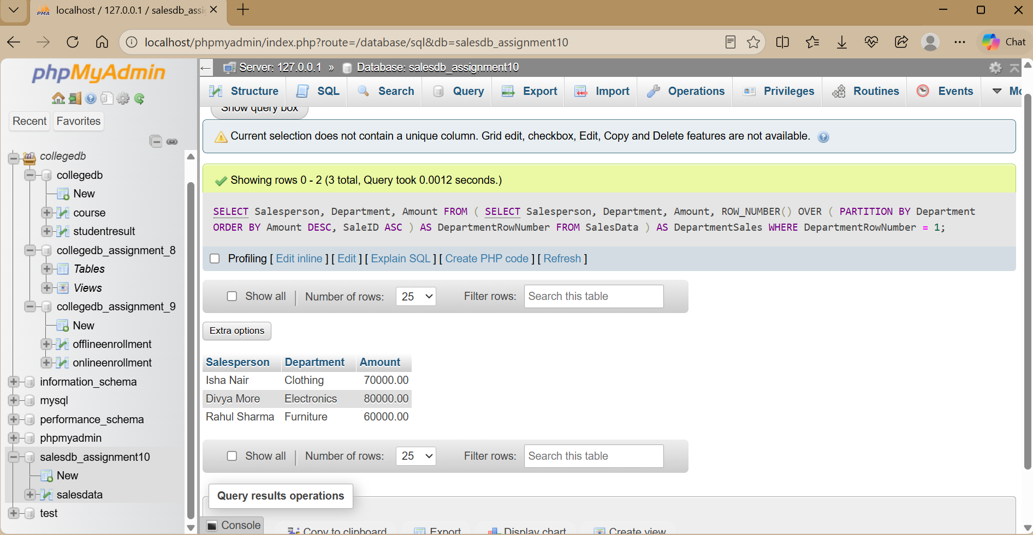

The inner query numbers salespersons within each department. The outer query keeps only row number 1 from every department.

THANK YOU

